**Hypothesis Testing Lab**

* **Screenshots of the codes and explanations**

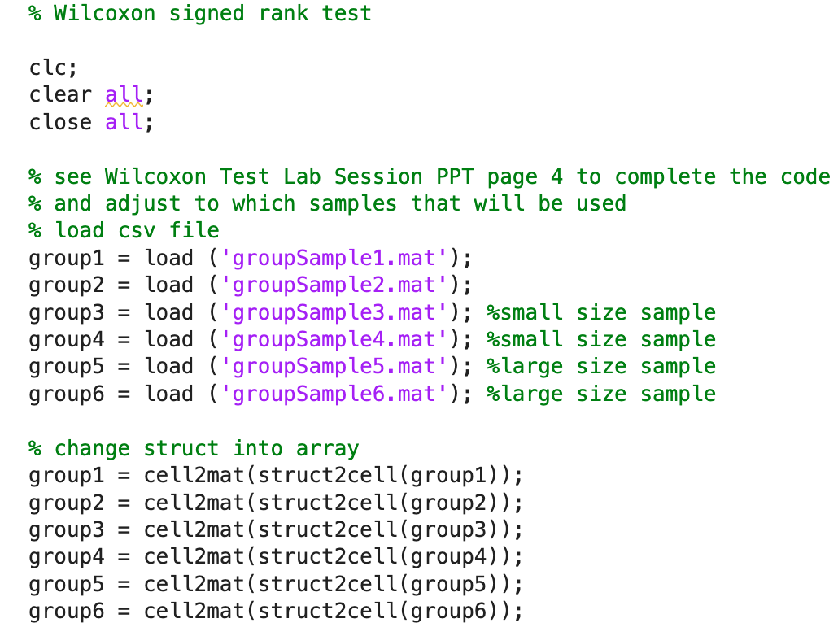

First, we start by loading the files containing the data we need for our analysis. Second, we address the issue of data types. We've encountered errors, specifically with structs, which have hindered our ability to perform calculations involving "-". To resolve this, especially for the signrank step, we've changed the data into arrays. This conversion simplifies the data structure and ensures compatibility for the testing process.

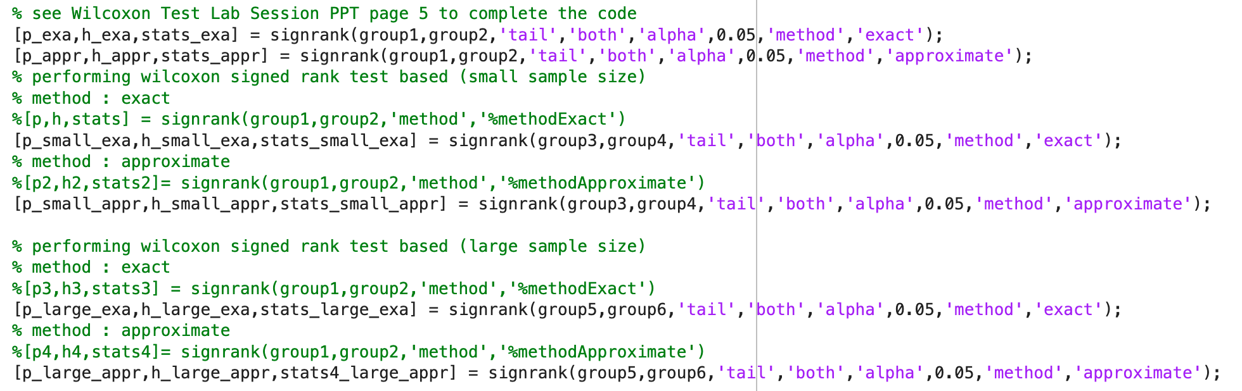

Next, we perform the ranking test methods.

* **Result of exact and approximate (p-value[p] and decision[h]) from small and large sample size**

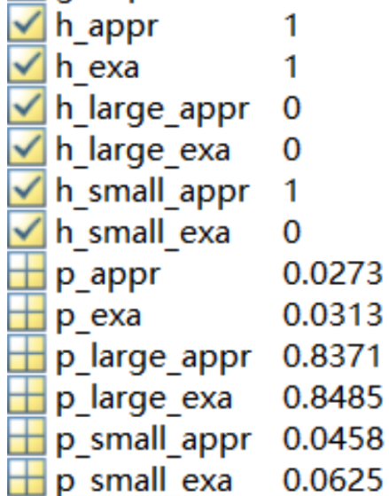

table of all the result:

|  | decision[h] | p-value[p] |
| --- | --- | --- |
| Group 1+2 exact | 1 (p<0.5) | 0.0313 |
| Group 1+2 appropriate | 1 | 0.0273 |
| Group 3+4 (small) exact | 0 | 0.0625 |
| Group 3+4 (small) appropriate | 1 | 0.0458 |
| Group 5+6 (large) exact | 0 | 0.8485 |
| Group 5+6 (large) appropriate | 0 | 0.8371 |

* **Comparison between exact and approximate methods**

From the table above, it indicates two discoveries. Firstly, the exact methods consistently yield higher p-values compared to approximate methods. Secondly, the p-value ratio tends to be higher for larger datasets than for smaller ones, as shown in the table.

* **Analyze if there are different hypothesis results from different sample sizes**

Using different test methods, such as the T-test, may yield different results. In the video, we learned that the T-test employs a different decision criterion for ranking p-values as non-significant, potentially leading to different conclusions. Moreover, the T-test may not produce reliable results when dealing with datasets containing a lot of outliers.